**HCI PROJECT REVIEW-2**

**SUBMITTED BY:**

**P S PRANEETH**

**THEME:** **Class Attendance Management Problem**

**I. Conduct Survey with the target group users**

**1)Introduction about Survey:**

Get into the world of attendance management survey. The motto of this survey is to take the feedback of the attendance capturer prototype and changes to be updated in product which makes it highly user-friendly and analyze the functionalities and tasks involved in the product. It works on sensor basis machine when student enters the class it detects them and give attendance partially to their presence, after faculty enters the partially gets locked then she can modify if necessary. The survey is dynamically driven by your responses it takes 10 minutes to complete.

**2)Provide the Questionnaire:**

1. **Do you think that the system of attendance capturing is useful to teachers and easy to use if so why?**

Yes, it reduces burden

Yes, as faculty can cover much concept in that time

Yes, than biometric this saves time

No, As proxy attendance can be given easily

Yes, it is user-friendly

Yes, it’s better way

No, sometimes maybe modifying is unable id deadline time exceeded in this process

Yes, easier to teachers

Yes, updating attendance separately is time waste

No, as system is new it may have many bugs

1. **Do faculty require total average attendance percentage of each student in respective subject?**

Yes

Yes

Yes

Yes

Yes

No

Yes

Yes

Yes

Yes

1. **As the system is new do you think there are numerous drawbacks if yes describe briefly?**

Yes, it may have many bugs

No

No

No

No

Yes, maintenance may be difficult

No

No

Yes, it may cause hesitation physically it’s big size

No

1. **Many students try to escape from class while faculty is unaware of them so does it require any feature to notify?(Options given below)**

**a. Alarm**

**b. Automatic door lock system**

a

b

a

a

b

b

b

b

a

a

1. **Do the prototype will be applicable as a high fidelity(mostly finished) prototype?**

Yes

Yes

Yes

Yes

Yes

No

No

Yes

Yes

Yes

1. **Can you suggest some features to be added?**

Blink when attendance is registered

Message to be sent to student after registered

Fingerprint as optional if system is not working

If Student leaves/escapes before class completion attendance should be cancelled

Face recognition can be added as extra feature

Automated door to lock after faculty entered

Id card should be notified even in any posture

Fingerprint to be as optional

Work even without electricity by storing in battery

If sensors not working message to be sent to technical department for resolving.

1. **Can you explain briefly the advantages of the system?**

Reduces admin work by capturing into database

Manual work for data retrieving is less

Easy access for students as well teachers

Time saving process

Error less and it doesn’t takes place mostly

Eliminates automatically the duplicate entry

Auto generation of attendance reports

Message will be sent to parents about attendance

Notifies student if debarred

Organizes attendance updated

1. **What do you think the system related is working on basis of ?**

Radio frequency identification

Body sensor identification

Radio frequency identification

Radio frequency identification

Id Card barcode scanner

Id Card barcode scanner

Radio frequency identification

Body sensor identification

Body sensor detection

Id Card barcode scanner

1. **Do this system depend on resultant interface or product?**

Product(ID Card)

Interface(Barcode based)

Interface

Interface

Interface

Interface

Interface

Interface

Product

Product

1. **What are errors might occur?**

Duplicate entries may not be notified

As it is early access error rate may be more

Without electricity may stop functioning

If automatic sensors frequent problems may occur

Duplicate entries may be notified

Proxy can be noticed

Duplicate entries might get registered

Duplicate entries may be notified

If automatic sensors frequent problems may occur

If automated sensors problems may occur

**3)Mention target group users and provide one Sample answered survey with snapshot while conducting survey.**

Target users are **Teachers/Faculty**.

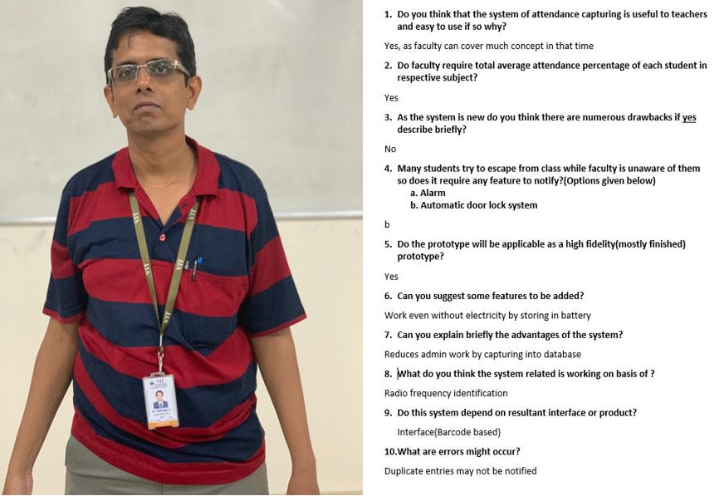

**4)Report:**

**II. With the user’s data and your design ideas finalize the functionalities for your new product.**

**1. Perform Task analysis for the finalized functionalities.**

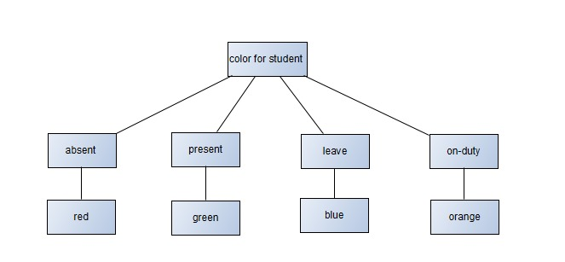

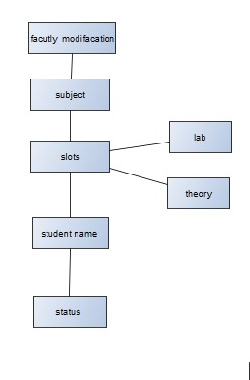

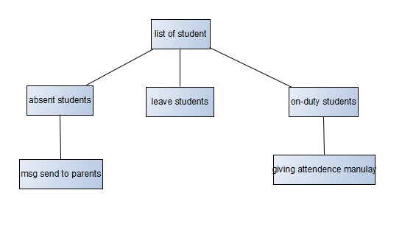

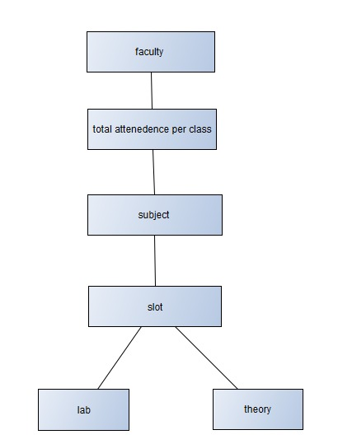

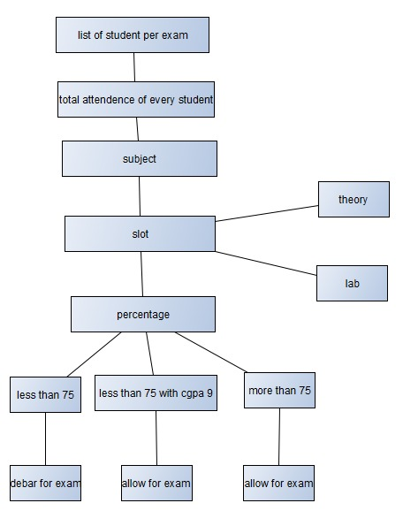

**III. Perform Prototyping (Storyboarding):**

Process takes place to notify the students as debarred if attendance is 75% below exempting 9 pointers.

